Name:_____________________________

1.1 - Bering Strait Hypothesis

I First Migration to North America (Asia to Alaska)

- The ____________________________ hypothesis is the most widely accepted theory of how _____________ __________________ was first settled
First Migration - Beringia Crossing
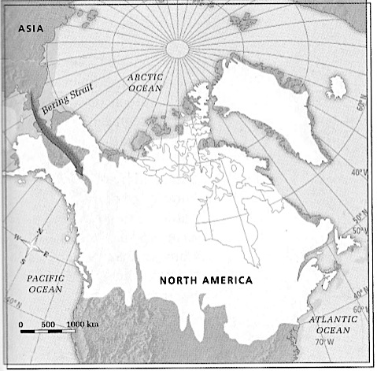
- First occupants initially migrated to __________________ 32 000 years ago:

- Due to the ___________________________, sunken sea levels caused immense plains to emerge

- These plains would have linked ____________ to ___________________ – Bering Strait (Beringia)

- _______________ followed _______________ from Asia to the Americas via Bering Strait

II Subsequent Migrations
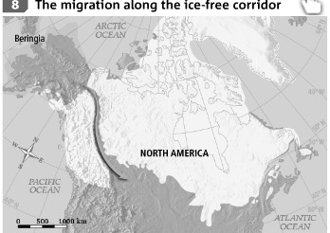
- For thousands of years’ nomadic populations occupied Alaska and the Yukon

- Large ___________________________ prevented them from migrating south

An Ice-Free Corridor

- Approximately _____________ years ago, an ice-free corridor emerged

- This allowed the first Aboriginal people to travel south and settle in _____________________________________________

Settlement of Quebec

- Glaciers continued to melt another northern territories emerged
- This allowed for Native peoples settled in present -day ___________________ -approximately __________________ years ago

Ancestor of the Inuit

- Ancestors of the ______________, the ______________ arrived in the Arctic from present day Alaska, much later on – by the year ____________

