Name: _______________________________________ Date: ________________________________

1.4 - First Contact with Europeans

Guiding Question: How did Native peoples contribute to France’s exploitation of the territory’s resources as well as its attempt at settlement?

I. European Exploration in North America -16th Century

Motivations of Early Explorations
Silks
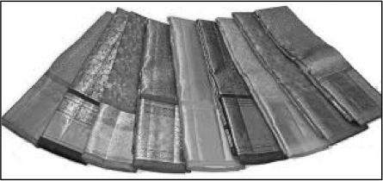
- Initial motivation:
Spices
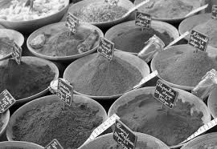
- For years Europeans traveled over land to central Asia and the Far East to obtain valuables such as ________________, ________________ & ________________.
Cotton

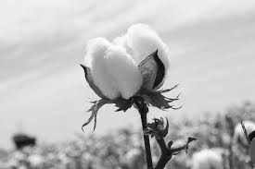
  - In the late 15th century Turkish armies captured Constantinople, making the trade route extremely dangerous

  - Europeans started searching for _________________________ to Asia

B) Other motivations:

- Expand _________________________
- Profit – rare goods
- Religion – Spread ____________________________
- Fame

Key European Explorers

Christopher Columbus – Spain _______________ claimed the Caribbean for the Spanish king

John Cabot – England 1497 discovered the abundance of _____________ on the east coast of North America

Giovanni de Verrazano – ___________________ 1524 sent to explore North America and find a route to Asia – was not successful
II. European Fishermen and Whalers

Event on the eastern coast of Noth America

European fisherman regularly visited eastern coast of North America to fish for:

- Cod

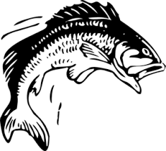
- Europeans came to ________________ cod on the east coast of North America - _________________________________

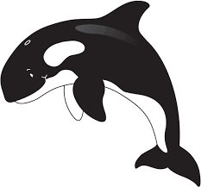
- Reason for Demand: Most _________________________ ate fish every _____________________

- Whales

- They also caught whales on the south shore of Labrador

- Reason for demand: The blubber was melted into oil and used to light _________________ in Europe.

III. Early Trade Between Native Peoples and Europeans

First Contact

- While exploiting fish and whales, Europeans began making ___________________ with Native peoples

- They formed a mutually beneficial trade relationship

Products Traded
Natives Obtained: | French Obtained
- ____________________ beads  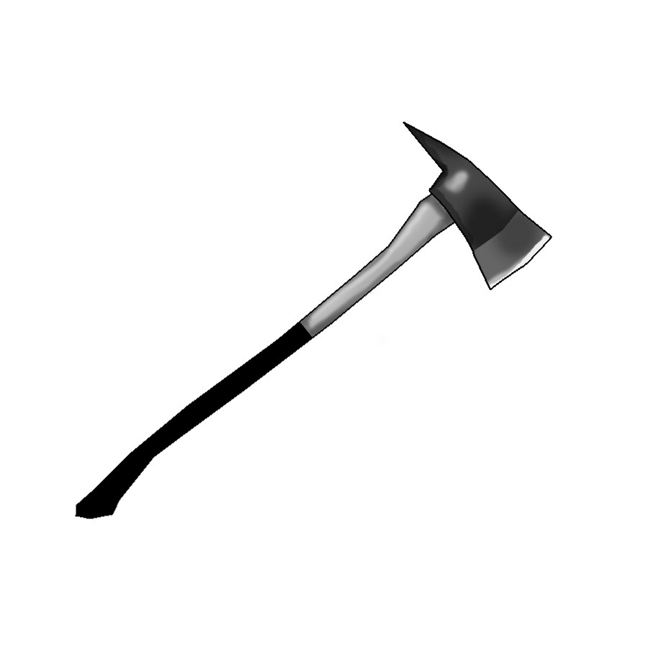  - Axes  - Knives  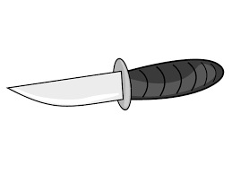  - Hammers  - Nails  - Copper Pots  - European _____________________  - Foods like peas, flour and salt | 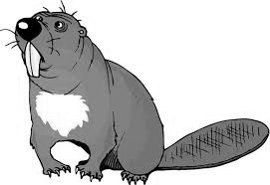  _______________

Demand: Fur coats and hats were in _________________ all over Europe.

The impact of Trade on Indigenous Peoples

  - Benefitted from various European goods/tools (see above)

  - Gradually __________________________ certain subsistence activities and traditional practices to obtain furs for Europeans:

      - ___________________ pots replaced traditional bark/wood pottery

      - Mi’kmaq began ______________________________ to obtain more furs

  - Established native trade relations were disrupted

  - Created/Intensified conflicts between certain Native nations

  - ____________________________ was impacted by the European exploitation of resources

IV. Jacques Cartier’s Voyages

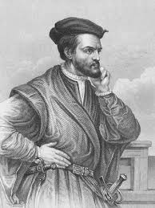
France sent Jacques Cartier on three voyages to New France in 1534, 1535, 1541 with 3 main objectives:
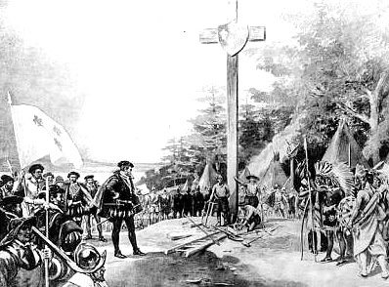
  - Find a ________________ to _________________

  - Create a competitive colonial empire/expand territory

  - Find ____________________

Voyage 1 – 1534

- _______________________ land in the name of the King by erecting a cross at Gaspe

- Failed to find riches

- Made first contact with the aboriginals, some of who were taken back to France

Voyage 2 -1535

- Explored St. Lawrence river, leading him to believe he found a route to Asia

- Reached Hochelaga (Montreal) but returned to Stadacona (Quebec) for the winter where many of his men died from _______________________

- Iroquois taught the French how to survive winter

- _____________________ erupted between the Indigenous people and the French

Voyage 3 -1541: Attempted Settlement at Cap Rouge

- Cartier was sent to New France under the leadership of Roberval with two new objectives:

- To establish a ___________________ (populate and develop New France)
- Evangelize the natives

- In hopes of achieving his goals, he erected two _______________ at the mouth of Riviere du Cap Rouge and settled there with his men

Voyage 3 -1541: Failures at Cap Rouge

Jacques Cartier failed to colonize New France because:

- The harsh ____________________ made settlement unappealing & difficult

- Cartier and Roberval could not agree on important decisions

- France was preoccupied with the ______________ in Europe

- Cartier abandoned his mission thinking he had found gold and diamonds, only to realize it was actually pyrite & quartz

- ______________________ between the natives and the French

V. Closer Relations between the First Nations and the French

Tadoussac - 1600

- The French set up a first fur ____________________________ at Tadoussac in 1600 in order to centralize trade with the First Nations

Franco – Aboriginal Alliance of 1603

- The French form an official alliance with the Maliseet, Innu and _______________________ in 1603

- The French gained a constant supply of ____________ and the First Nations gain military __________________ and European goods

