Name: _______________________________________ Date: _______________________

1.2 - Social Relationships among Indigenous Peoples
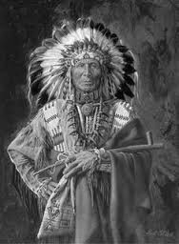
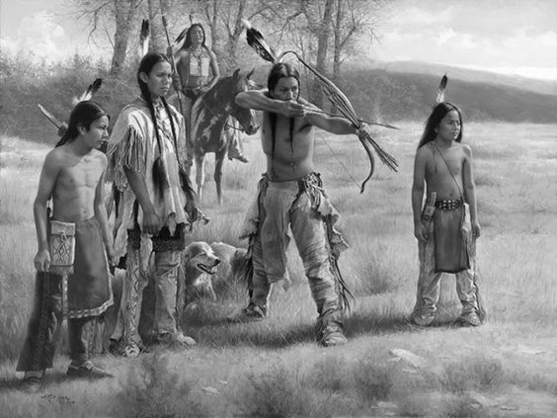
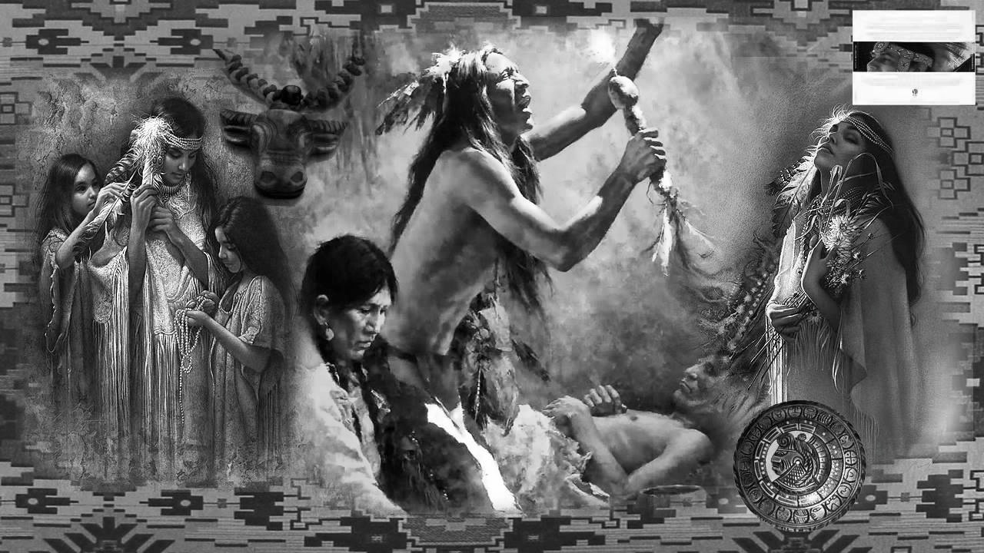

I. Social Organization

- Algonquians and Inuit had a ________________________ and __________________________ social organization, well adapted to their nomadic way of life

- Iroquioan villages were made of hundreds – and sometimes thousands of people, which required a more _________________________ social organization and suited their sedentary lifestyle
Algonquians
Inuit
Iroquoians

Nuclear & Extended Family
- One longhouse
- Several related families
- From the same matrilineal lineage & clan
Nuclear Family

- Parents & children
- One family per wigwam
Nuclear Family
- parents & children

Clan

- Families descended from same maternal ancestor
- Clans were designated by a totemic ___________________
Hunting Group

- ______________ families

- 10 - 20 people - fall & winter
The Camp

- Several nuclear families joined together to form camps of different sizes based on the season:
  - 100 in winter
  - 10-20 in spring

Band
- Several families
- 100 - 200 people – spring & summer
The village

- Several ___________________ living together

Nation

- All ________________ that share the same language and culture

- Defended and expanded territory
Nation

- Several villages sharing _____________________________ and culture

The Confederacy

- Many nations joined together for common interests (defense)
II. Decision Making

Inuit | Algonquians | Iroquois
- Most decisions were made collectively and by ______________________  - Decisions were often influenced by ____________________ in the community | - Daily decisions were made by the chiefs  - Complex decisions were made by _____________________ | - Decisions made by chiefs and various councils:  - War chiefs  - civil chiefs  - Council of elders  - Council of women  - Council of warriors

Choosing the Chiefs
Among both the Algonquians and Iroquoians, chiefs were selected based on their bravery, _________________________ and generosity:

Bravery/Courage

- Men would show their bravery when ___________________ and during __________

- Female bravery was measured at the time of _______________________________

Eloquence

- The quality of someone who ___________________________________ and is persuasive

Generosity

- Sharing resources to maintain social ties

- Natives felt it was their duty to give, receive and give back

III. Oral Tradition

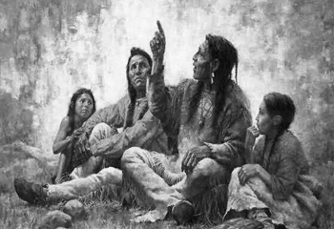
- Native communities conveyed culture and knowledge ________________ through storytelling
- _________________ were assigned the role of telling these stories & held a strong influence in soceity
- Stories were used to explain the relationship between humans and nature
- Different types of stories were used for different purposes:

- Mythology was used to teach religious values and customs
- Creation legends were used to explain the _____________________ of the world

IV. Indigenous Spirituality
Spiritual Practices

- Indigenous spirituality was closely tied to the ________________________________
- Indigenous people believed that all elements of the environment had a spirit
- They communicated with the spirit world through various rituals
Inuit Amulet – protected and brought good luck to the hunter
Relationship with Animals
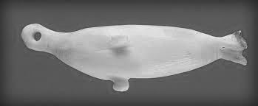
- Their unique relationship with animals was portrayed in their ____________________ practices

- Successful Hunt was based on:

- The hunter’s _____________________ for the animal’s spirit

- Mi’kmaq did not burn any animal bones out of respect

- The animal’s willingness to give itself up to the hunter
Shamanic Traditions

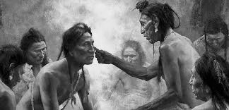
Individuals called ____________________ had a superior power that enabled them to communicate with the spirit world.

They could:
- Predict the ______________________
- Interpret ____________________
- Have more frequent visions
- ________________ people
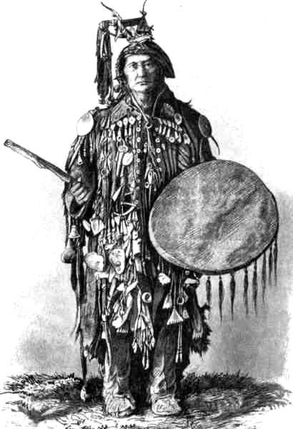
- Ward off evil
