Name: _________________________________________

3.3 – 3.5: Quebec, 1760-1791

PART 1: Quebec Act - 1774

- Based on Carleton’s recommendations the British adopted a ______________________
- Goal: __________________ the French Canadians so they would not join the Americans in their revolt
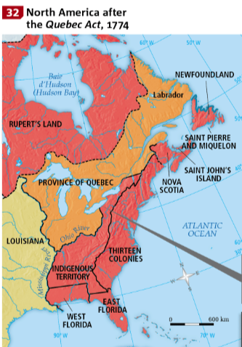
- 3 major changes:
  - _______________________
  - Political
  - Religious
- Appease: To satisfy a demand

Territorial Change
- The territory of the province _______________ almost 3 times bigger
- Now included part of the _________________ Valley, a region coveted by American colonists

Political Change

- Abolition of the Test Act - a new oath of allegiance to the King of England replaced the Test Act.
- Eight French Canadiens were to be included in the council
- Seigneurial System was officially recognized

Religion

- Catholicism was officially permitted and the ______________________ could once again collect the ___________________. The Bishop could also appoint a successor.

Reactions to the Quebec Act

GROUP | REACTIONS
The Canadiens | - SEIGNEURS: pleased since Seigneurial system was recognized  - CHURCH: Catholic religion was recognized  - MERCHANTS: Pleased that the fur trading territory was expanded.  - CANADIENS: Happy - Catholic religion was recognized. Upset - had to pay the tithe and seigneurial dues.
British of Province | - GOVERNOR AND HIS ALLIES: happy with the new constitution  - MEMBERS OF THE ENGLISH PARTY: Unhappy with Reinstatement of French civil law. But Pleased with the western expansion of the fur trade territory.
The 13 Colonies | - Unhappy with the concessions made to Catholics  - Losing the Ohio Valley deprived fur traders of the Great Lakes region.

PART 2: American Revolution

Causes of Unrest

- Starting in 1763 – London made many decisions that caused unrest in the 13 colonies:

    - Territorial changes - Royal Proclamation deprived them of the _____________________________.

    - ___________________________ – imposed on certain products (Sugar, Stamps, Glass, Tea) in the colony.
    - ____________________________________ – gave the East India a monopoly on the tea trade, an unfavorable advantage over the industry

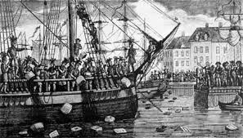
Boston Tea Party

- In response to the Tea Act, British colonists stormed three ships in Boston Harbor and threw chest of ___________ overboard.

- This event became known as the __________________________________________.

Intolerable Acts

- 1774 - In reaction to the Boston Tea Party, London adopted “the Intolerable Acts”
- This meant the colonies could no longer elect their own representatives.
- In response, the 13 Colonies organized a resistance movement.
- 1775 - The13 Colonies declared war against the mother country to fight for their independence

Impact of the American Revolution on Quebec

1. Letters to the Canadiens
- In 1774, the 13 colonies wrote a letter to the inhabitants of the Province of Quebec to join them
- Most Canadiens chose to remain neutral

2. Invasion of the Province of Quebec
- In 1775, the armies of the 13 Colonies occupied Montreal and held Quebec under siege in hopes of gaining Canadien support.
- Some Canadiens joined the revolution, while others remained neutral

Treaty of Paris - 1783
- The colonists won the war and earned their Quebec’s territory and population. independence, creating the United States of America
- In 1783, the Treaty of Paris was signed
- The victory impacted the territory and population of Quebec

Territory
- Province of Quebec lost the southern region of the Great Lakes and the Ohio Valley, which were integrated into the territory of the United States of America
- Native-designated territory was eliminated

Population
- Colonists from the 13 colonies who remained loyal to the British during the American Revolution came to Quebec
- 7000 Loyalists left America, increasing the number of Anglophones from 1% to 10%
- Loyalists joined the British Party and began demanded and English rights
QUEBEC ACT TREATY OF PARIS

PART 3 - Transformation of Colonial Society, 1760-1791​

I. Population and Society
- Population is mostly Francophone and Catholic for 30 years after the Conquest
- Few thousand Native people
- Over a thousand black people, mostly slaves

Emergence of professional Bourgeoisie:

- Doctors, lawyers, notaries, different types of merchants
- Start learning English in order to get involved in trade
- Increased political role – joined the British merchants in demanding a legislative assembly
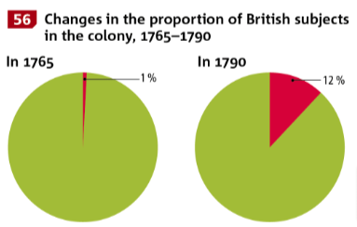
British Immigration
- Composed of merchants, soldiers and civil servants
- British Immigration increases after American Revolution because of the arrival of loyalists

Fur Trade
- Fur trade remained the ____________ economic activity
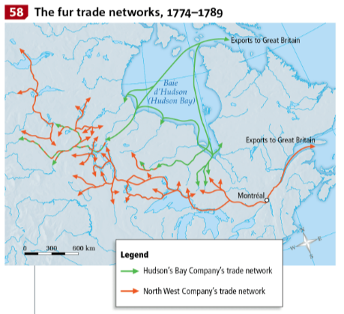
- British merchants replaced the French merchants
- Most Canadiens worked as voyageurs
- Two major companies were in competition: the ______________________________________ Company and the ______________________________________ Company

Religion
- After the Conquest, the Catholic Church & the Anglican Church had to coexist
- Catholic Church faced difficulties but continued its social role
  - Still ran hospitals and schools
- Catholic Church allied itself with the British
- Anglican Church gradually established itself, and oversaw the education of young people

